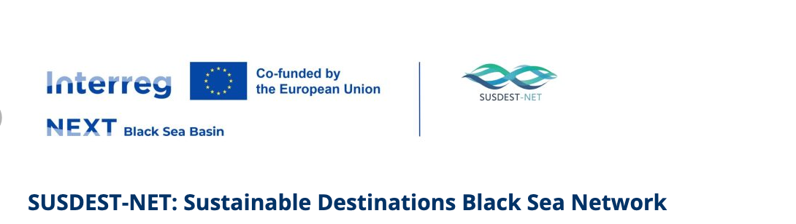

BSB00884

SUSDEST-NET: Sustainable Destinations Black Sea Network
www.susdestnet.com
Lead partner:
- Municipality of Kavala
Partners:
- Union of Bulgarian Black Sea Local Authorities (UBBSLA), Bulgaria
- Democritus University of Thrace-School of Management Science and Accounting-Special Account for Research Funds DUTH, Greece
- Chisinau City Hall Moldova
- Limanu Municipality, Romania
- Uskudar Urban Services Trade and Industry Joint Stock Organization, Türkiye
Funded: (Interreg VI-B) NEXT Black Sea Basin Programme; Programme priority Blue and Smart Region; Specific objective RSO1.1: Developing and enhancing research and innovation capacities and the uptake of advanced technologies
Duration: 30 months (04.11.2025 – 03.05.2028)
Total budget: 1.415.719,10 EUR

The SUSDEST-NET project addresses common challenges in the Black Sea Basin region, which includes Greece, Bulgaria, Romania, Moldova, and Turkey. This area faces issues such as overreliance on tourism, leading to environmental degradation, pollution, and unsustainable resource use. Climate change, economic disparities, and insufficient infrastructure further exacerbate these problems. Additionally, a lack of coordinated policies and governance structures results in fragmented efforts to manage tourism sustainably. The SUSDEST-NET project addresses the urgent need for sustainable tourism in the Black Sea Basin by promoting innovative solutions and transnational cooperation
The overall objective of SUSDEST-NET is to promote ESG (Environmental, Social, and Governance) sustainability principles for 5 tourism destinations in the area who will establish their Destination Management Committees (DMCs). The project aims to transform these destinations into sustainable, competitive, and attractive areas, supporting the blue economy and enhancing the region’s profile, deriving from the adoption of sustainable practices, improving environmental quality, social equity, and economic viability. This will attract responsible tourists, boost local economies, and preserve the region’s natural and cultural heritage for future generations.
- The project will develop a common sustainable tourism policy and strategy, providing a harmonized framework for guiding sustainable tourism practices. This includes creating a versatile training package with modules, case studies, and practical exercises on sustainable tourism practices, delivered through e-training sessions. AI tools such as the AI Recommendation and Monitoring System (AIREMS) supporting sustainability of destinations and a Sustainable Destinations Observatory will provide real-time data and insights to monitor and recommend sustainable practices. The Sustainable Destination Education and Collaboration (SDEC) platform will facilitate knowledge sharing and collaboration among stakeholders.
- Pilot implementations will design and implement prioritized actions from sustainability plans using the RADAR methodology, serving as practical examples for other regions. A sustainability awarding scheme will recognize destinations’ excellence in sustainable tourism, and targeted marketing campaigns along with participation in an international tourism fair will promote sustainable destinations in the region.
Transnational cooperation is essential for addressing shared environmental, social, and economic challenges in the Black Sea Basin. By working together, project partners can leverage diverse expertise, share best practices, and develop innovative solutions effective across different contexts. This cooperation ensures broader impact and contributes to the region’s overall sustainability.
The project is innovative in several ways. It adopts a holistic approach to sustainability by integrating ESG principles into all aspects of destination management, addressing environmental, social, and governance dimensions comprehensively. SUSDEST-NET leverages AI and digital platforms for realtime monitoring and recommendations, representing a significant advancement over current practices. The development of a common sustainable tourism policy and strategy promotes transnational cooperation and consistency. The SDEC platform integrates interactive and collaborative features, fostering a community of practice.

